RabbitMQ on Ubuntu

* Update Ubuntu repositories:

To update Ubuntu, use this command: **sudo apt-get update**

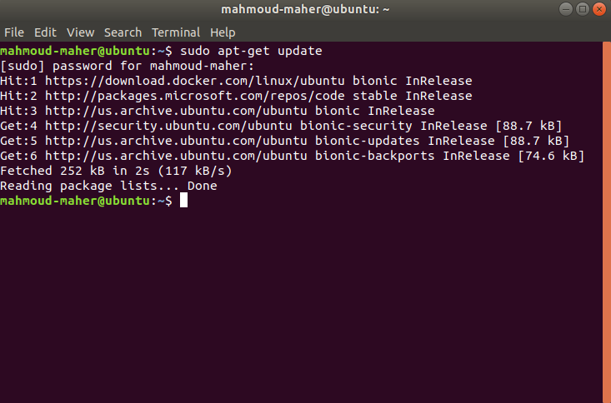

* Prerequisites:

RabbitMQ runs on Erlang virtual machine. So that to install/run the RabbitMQ, initially we have to install the Erlang. If you already installed Erlang on your machine, you can skip this step and directly move to RabbitMQ installation.

* Install Erlang on Ubuntu:

To install Erlang on Ubuntu, use this command: **sudo apt-get install erlang**

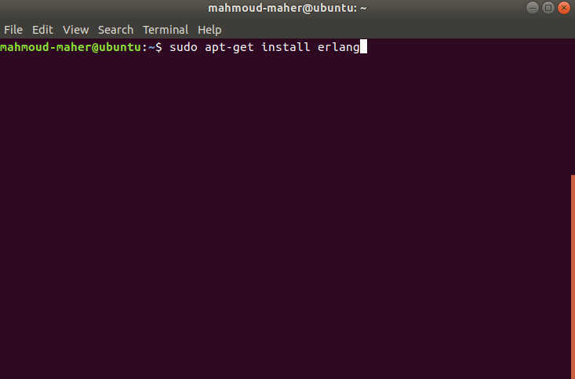

* Install RabbitMQ

To install RabbitMQ on Ubuntu, use command: **sudo apt-get install rabbitmq-server**

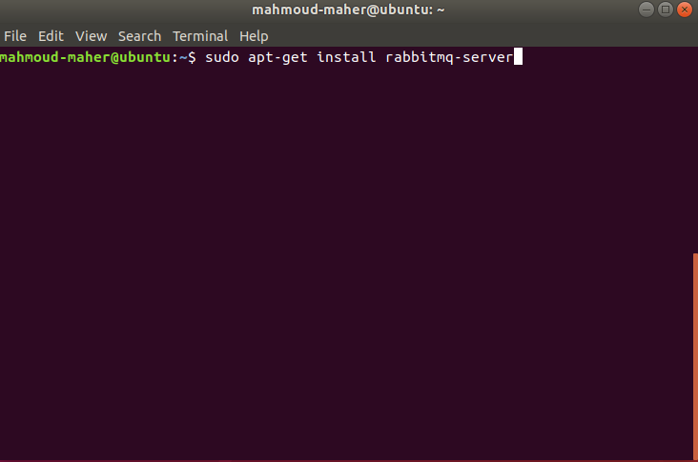

* Start RabbitMQ Server

You Can Start RabbitMQ server by Running **sudo systemctl start rabbitmq-server**

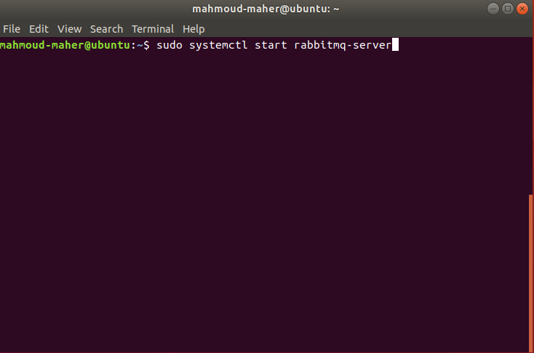

* Stop RabbitMQ Server

You Can Stop RabbitMQ server by Running **sudo systemctl stop rabbitmq-server**

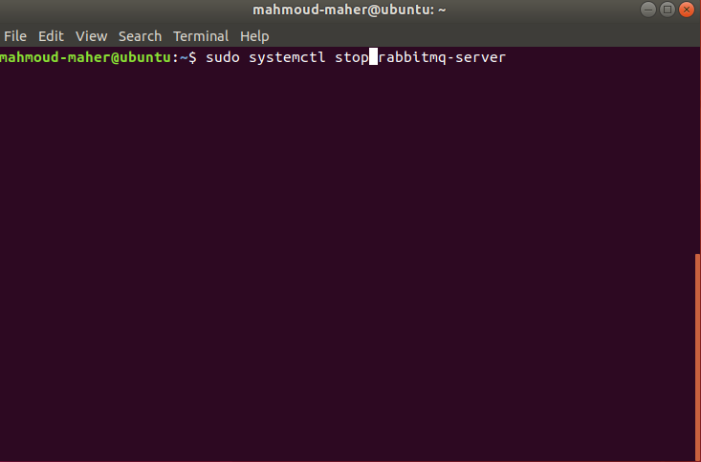

* RabbitMQ Server Status

Check RabbitMQ server status by Running **sudo systemctl status rabbitmq-server**

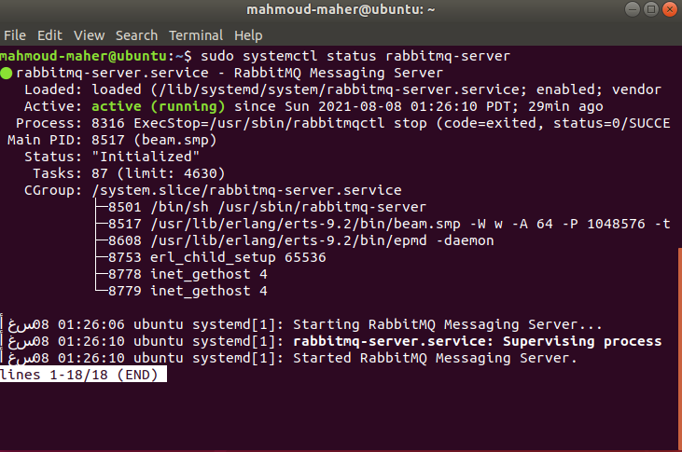

* Enable RabbitMQ Management Plugin

To enable management plugin, use this command:

**sudo rabbitmq-plugins enable rabbitmq_management**

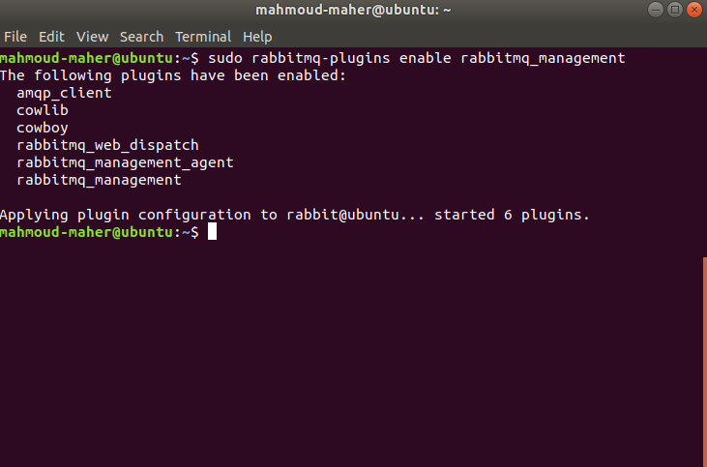

* Navigate RabbitMQ Management Plugin

To check everything as expected open any browser and access the <http://localhost:15672>URL then you would see the below RabbitMQ login page.

Default credentials are:

**User Name**: guest

**Password**: guest

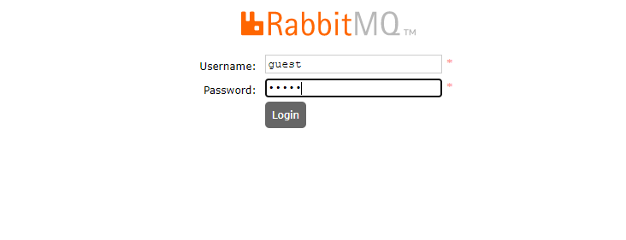

* Navigate RabbitMQ home page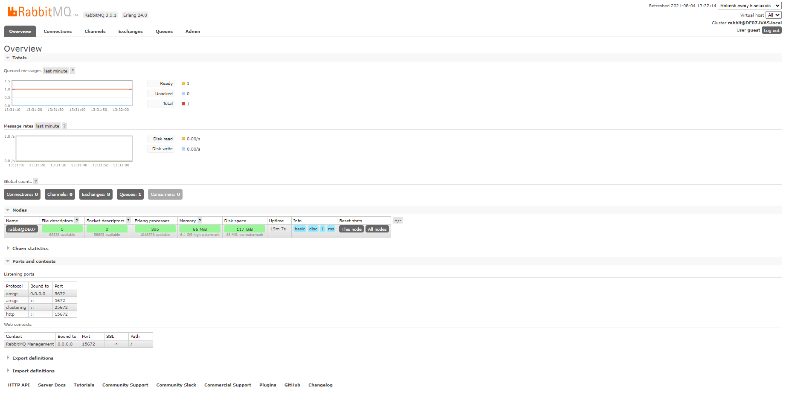
* RabbitMQ Ubuntu Monitor

You can watch message send and received to RabbitMQ by observe the overview section

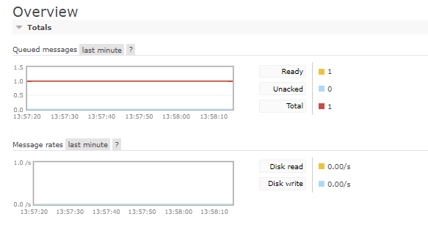

* RabbitMQ Windows Default Configuration for Laravel

